

**The Forgotten Florence**

|  |  |
| --- | --- |
| **“The Dark Path of Lonely King”** | **Simge Haksal – 923606**  **Mode:** Single-Player  **Genre:** Adventure  **Story Type:** Linear Story  **Camera:** Third Person  **Platform:** Windows |

**TABLE OF CONTENT**

Visual References 5

Table References 7

Change Log 8

1. Project Guidelines 10

1.1. Paths and Project Structure 10

1.2. Data Storage and Access 10

1.3. Naming Convention 11

1.4. Tools, File Type & Format 12

2. High Concept 13

2.1. Periodic Table of Storytelling 13

2.1.1. Structure 13

2.1.2. Setting, Laws & Plots 13

2.1.3. Heroes 13

2.1.4. Character Modifiers 14

2.1.5. Villains 14

2.1.6. Metatropes 14

3. Concepts 15

3.1. Game Analysis 15

3.2. Project Setup 15

3.3. Platform 15

3.4. Functionality 15

3.5. Target Audience 15

3.6. Player’s Skills and Interaction Ways 15

4. Game Settings 17

4.1. Locations 17

4.2. World Diagram 17

4.3. Goal Outline 18

5. Themes 18

6. Synopsis 19

6.1. Premise 19

6.2. Act 1- Setup 19

This act take place in level 1 19

6.3. Act 2- Confrontation 19

This act take place in level 2, 3, 4 and 5 19

6.4. Act 3- Resolution 19

This act take place in level 6, 3 and 1 19

7. Story 20

7.1. Complete Story of the Level 20

7.2. Dialogues on the Level 22

8. Characters 23

8.1. Sophie Hatter 23

8.1.1. Description 23

8.1.2. Backstory 23

8.1.3. Circumflex and Relationship Map 23

8.2. Calcifer 24

8.2.1. Description 24

8.2.2. Backstory 24

8.2.3. Circumflex and Relationship Map 24

24

8.3. Howl 25

8.3.1. Description 25

8.3.2. Backstory 25

8.3.3. Circumflex and Relationship Map 25

8.4. The King Mario di Marcello 26

8.4.1. Description 26

8.4.2. Backstory 26

8.4.3. Circumplex and Relationship Map 26

8.5. Girolamo Riario-The Enemy 27

8.5.1. Description 27

8.5.2. Backstory 27

8.5.3. Circumflex and Relationship Map 27

8.6. Zeppy – The Evil Twin 28

8.6.1. Description 28

8.6.2. Backstory 28

8.6.3. Circumflex and Relationship Map 28

8.7. The Princess Veronica 29

8.7.1. Description 29

8.7.2. Backstory 29

8.7.3. Circumflex and Relationship Map 29

8.8. Interpersonal Circumflex 30

8.9. Relationship Table 30

9. Detailed Level Description 31

9.1. Level Flowchart 31

9.2. Event Diagram 32

9.3. Documents Level 33

9.4. Area Description 34

9.4.1. Howl’s Moving Castle 34

9.4.1.1. Inside the Castle 34

9.4.1.2. Outside the Castle 35

9.4.2. The Hatter 35

9.4.3. Palazzo di Nuovo 35

9.4.4. Chapel di Amore 35

9.4.5. Chiesa Fiorentino 36

9.4.6. Galleria di Angelo 36

9.5. Check Point 36

9.6. Detailed Area Description 37

9.6.1. Howl’s Moving Castle 37

9.6.1.1. Background Music 37

9.6.1.2. Lighting 37

9.6.1.3. Mood and Colors 37

9.6.1.4. Level Flowchart 38

9.6.2. The Hatter 39

9.6.2.1. Background Music 39

9.6.2.2. Lighting 39

9.6.2.3. Mood and Colors 39

9.6.2.4. Level Flowchart 40

9.6.2.5. Rewards in the Level 40

9.6.2.6. Heath Potion 41

9.6.3. Palazzo di Nuovo 42

9.6.3.1. Background Music 42

9.6.3.2. Lighting 42

9.6.3.3. Mood and Colors 42

9.6.3.4. Level Flowchart 43

9.6.4. Chapel di Amore 44

9.6.4.1. Background Music 44

9.6.4.2. Lighting 44

9.6.4.3. Mood and Colors 44

9.6.4.4. Level Flowchart 45

9.6.4.5. Rewards in the Level 45

9.6.5. Chiesa Fiorentino 46

9.6.5.1. Background Music 46

9.6.5.2. Lighting 46

9.6.5.3. Mood and Colors 46

9.6.5.4. Level Flowchart 47

9.6.5.5. Rewards in the Level 47

9.6.5.6. Important Detail of the Level 48

9.6.6. Galleria di Angelo 49

9.6.6.1. Background Music 49

9.6.6.2. Lighting 49

9.6.6.3. Mood and Colors 49

9.6.6.4. Level Flowchart 50

9.6.6.5. Solving the Puzzle 51

9.6.6.6. Rewards in the Level 51

9.6.7. Score Map 52

9.6.8. Reward Map 52

9.6.8.1. First Reward 53

9.6.8.2. Second Reward 53

9.6.8.3. Third Reward 53

9.6.8.4. Forth Reward 53

9.7. NPCs Automata 54

9.8. Finite State Machine 55

9.9. Measurements 57

*9.9.1.* *Measurement for Characters* 57

*9.9.2.* *Measurement of the Obstacles* 57

*9.9.3.* *Measurement of the Mission Object* 57

9.10. Game & Level Scope 58

9.11. Fight Outcomes 58

*9.11.1.* Main Characters Statistics 58

*9.11.1.1.* *Sophie Hatter’s Stat* 58

*9.11.1.2.* *Calcifer’s Stat* 59

*9.11.1.3.*  *Zeppy’s Stat* 59

*9.11.1.4.*  *Girolamo’s (The Enemy) Stat* 59

9.11.2. Character’s Skills 60

9.11.2.1. Enemy’s Skills 60

9.11.2.2. Character’s Skills 60

9.11.3. Team’s Damage 60

9.11.4. Fight against Girolamo 60

9.11.5. Experience Tables 61

10. Reference List 61

# Visual References

**Figure 1.** *Periodic Table of Storytelling*

**Figure 2.** *World Diagram of the Project*

**Figure 3.** *Circumflex of Sophie Hatter*

**Figure 4.** *Relationship Map of Sophie Hatter*

**Figure 5.** *Circumflex of Calcifer*

**Figure 6.** *Relationship Map of Calcifer*

**Figure 7.** *Circumflex of Howl*

**Figure 8.** *Relationship Map of Howl*

**Figure 9.** *Circumplex of Mario di Marcello*

**Figure 10.** *Relationship Map of the King*

**Figure 11.** *Circumflex of Girolamo*

**Figure 12.** *Relationship Map of Girolamo*

**Figure 13.** *Circumflex of Zeppy*

**Figure 14.** *Relationship Map of Zeppy*

**Figure 15.** *Circumflex of Veronica*

**Figure 16.** *Relationship Map of the Princess*

**Figure 17.** *Interpersonal Circumflex of All Characters*

**Figure 18.** *Basic Flowchart of the Story*

**Figure 19.** *Event Diagram for Both Sophie and Calcifer Path*

**Figure 20.** *Small Map*

**Figure 21.** *Living Room of the Moving Castle*

**Figure 22.** *Entrance of the Moving Castle*

**Figure 23.** *The Balcony of the Moving Castle*

**Figure 24.** *The Hatter*

**Figure 25.** *Palazzo di Nuovo*

**Figure 26.** *Chapel di Amore*

**Figure 27.** *Chiesa Fiorentino*

**Figure 28.** *Galleria di Angelo*

**Figure 29.** *Howl’s Castle 3D Render*

**Figure 30.** *Howl’s Moving Castel Flowchart*

**Figure 31.** *Hatter 3D Render*

**Figure 32.** *The Hatter Flowchart*

**Figure 33.** *Palazzo di Nuovo 3D Render*

**Figure 34.** *Palazzo di Nuovo Flowchart*

**Figure 35.** *Chapel di Amore 3D Render*

**Figure 36.** *Chapel di Amore Flowchart*

**Figure 37.** *Chiesa Fiorentino 3D Render*

**Figure 38.** *Chiesa Fiorentino Flowchart*

**Figure 39.** *Galleria di Angelo 3D Render*

**Figure 40.** *Galleria di Angelo Flowchart*

**Figure 41.** *Number Puzzle*

**Figure 42.** *Score of Each Location*

**Figure 43.** *Rewards on the Map*

**Figure 44.** *Dialogue Puzzle*

**Figure 45.** *Defeat of Girolamo*

**Figure 46.** Meeting with the King

**Figure 47.** FSM for Collecting Items

**Figure 48.** FSM for the Fight

**Figure 49.** FSM for the Game Process

**Figure 50.** FSM for Winning the Fight

# Table References

**Table 1.** *Description of the Change Log*

**Table 2.** *Revision History*

**Table 3.** The Capitalization Rules

**Table 4.** Naming Convention

**Table 5.** *Personal Tool for Artists and Programmers*

**Table 6.** *Tool Used on the Virtual Machine*

**Table 7.** *Relationship Table*

**Table 8.** *Relationship Table*

**Table 9.** *Level Progression*

**Table 10.** *Statistic of Sophie*

**Table 11.** *Statistic of Calcifer*

**Table 12.** *Statistic of Zeppy*

**Table 13.** *Statistic of Girolamo*

**Table 14.** *Character’s Skill Table*

**Table 15.** *Expected Team Damage*

**Table 16.** *Expected Fight Damage*

**Table 17.** *Elf Saving Throws Table*

**Table 18.** Elf *Experience Table*

**Table 19.** *Magic User Saving Throws Table*

**Table 20.** *Magic User Experience Table*

# Change Log

**THE FORGOTTEN FLORENCE**

-The Dark Path of Lonely King-

|  |  |
| --- | --- |
| Purpose | This is a briefing document for following the process. |
| Creation date | 24.10.2018 |
| Current owner | Simge |
| Last modification | 10.01.2019 |

**Table 1.** *Description of the Change Log*

|  |  |  |
| --- | --- | --- |
| Revision History | | |
| Who | **When** | **What** |
| Simge | 24.10.2018 | Created this document |
| Simge | 29.10.2018 | Wrote the basic subjects of the project |
| Simge, Okan, Berkdeniz | 04.11.2018 | Set High concept and Game Settings |
| Simge | 05.11.2018 | Added World Diagram |
| Okan | 06.11.2018 | Added some concept |
| Berkdeniz | 06.11.2018 | Added and organized the concept |
| Okan | 07.11.2018 | Done the character subjects |
| Berkdeniz | 07.11.2018 | Done the character subjects |
| Simge | 07.11.2018 | Added map relations |
| Berkdeniz, Okan | 08.11.2018 | Made the circumflex of the characters |
| Simge | 08.11.2018 | Re-organized the circumflex of the characters then added it |
| Okan, Berkdeniz, Simge | 08.11.2018 | Founded a Title |
| Okan | 08.11.2018 | Edited Data Organization Template |
| Berkdeniz, Simge, Okan | 08.11.2018 | Looked over the project and re-organized some parts |
| Simge, Mahammad, Okan | 21.11.2018 | Checked all the mistakes of the first submission |
| Simge, Okan, Berkdeniz | 22.11.2018 | Looked for other projects of this year |
| Simge | 23.11.2018 | Corrected all the mistakes of the first submission |
| Mahammad | 24.11.2018 | Wrote complete story and dialogues |
| Simge | 25.11.2018 | Drew relationship map and fix their circumflexes |
| Okan, Berkdeniz | 26.11.2018 | Modified the data management file |
| Simge, Mahammad, Okan | 27.11.2018 | Looked over the Project before the second submission |
| Simge, Okan | 06.12.2018 | Got feedback from professors and corrected all the mistakes |
| Simge | 07.12.2018 | Designed logo and reorganized relationship maps |
| Simge | 08.12.2018 | Designed a new world diagram and specified locations |
| Simge | 09.12.2018 | Redesigned flowchart |
| Simge | 10.12.2018 | Started to write statistics part |
| Simge | 11.12.2018 | Wrote detailed area description |
| Simge | 20.12.2018 | Got feedback from Professors and corrected mistakes |
| Simge | 27.12.2018 | Created “GIT” project & fixed data management document |
| Simge | 28.12.2018 | Added Concept Chapter |
| Simge | 02.01.2019 | Added Server Activity Diagram |
| Simge | 03.01.2019 | Added Player’s Skills and Interaction Ways Part |
| Simge | 04.01.2019 | Draw detailed area design with measurements |
| Simge | 05.01.2019 | Added Event Diagram |
| Simge | 06.01.2019 | Added FSM and NPC Automata |
| Simge | 07.01.2019 | Added Flowcharts for Area in the Map |
| Simge | 08.01.2019 | Added Scores and Rewards, Showed on Maps |
| Simge | 09.01.2019 | Added Puzzles at the end of the Level |
| Simge | 10.01.2019 | Added Statistical Analysis Part |
| Simge | 22.01.2019 | Got feedback from Professors and corrected all the mistakes, deleted unnecessary parts |
| Simge | 23.01.2019 | Added Game and Level Scope, Level Progression, Enemy & Skill Description and Check Point |
| Simge | 24.01.2019 | Detailed description of just 1 level |

**Table 2.** *Revision History*

# Project Guidelines

We can say that this file is the data management file of this project.

## Paths and Project Structure

The project directory is the one that contain the “git” folder:

You can see the project structure below:

The Forgotten Florence

High Concept

Periodic Table of Storytelling

Resources

Characters

Name

Story

Reference Picture

Sounds

Objects

Name

Description

Reference Picture

Sounds

Levels

Flowchart

Maps

City Name

Zone

Description

Detailed Map

Reference Picture

Sounds

Rooms

Description

Reference Image

Sounds

Logos

Prototypes

Unity Project

## Data Storage and Access

The web-based hosting service for version control that we use is GitHub for Backup Google Drive by Simge, Okan and Mahammad.

**URL:** <https://github.com/simgehaksal/TheForgottenFlorence.git>

**Administrator:** Simge Haksal

## Naming Convention

We will use camel and pascal case for naming conventions. In Camel Case, each word is capitalized, except possibly the first word like lowerCamelCase. The Camel Casing convention used only for parameter names. Apart from camel case, there is also Pascal case. The Pascal Casing convention, used for all identifiers except parameter names, capitalizes the first character of each word like HtmlTag. A special case is made for two-letter acronyms in which both letters are capitalized like IOStream.

|  |  |  |
| --- | --- | --- |
| Identifier | Casing | Example |
| Namespace | Pascal | namespace System.Security { ... } |
| Type | Pascal | public class StreamReader { ... } |
| Interface | Pascal | public interface IEnumerable { ... } |
| Method | Pascal | public class Object {  public virtual string ToString();  } |
| Property | Pascal | public class String {  public int Length { get; }  } |
| Event | Pascal | public class Process {  public event EventHandler Exited;  } |
| Field | Pascal | public class MessageQueue {  public static readonly TimeSpan  InfiniteTimeout;  }  public struct UInt32 {  public const Min = 0;  } |
| Enum value | Pascal | public enum FileMode {  Append, ... } |
| Parameter | Camel | public class Convert {  public static int ToInt32(string value);  } |

**Table 3.** The Capitalization Rules

This level will implement on Unity Game Engine by using C# programming language. So that, the practical project will be written by using camel and Pascal casing. In the Pascal Casing, the class names and method names will be looked like that:

public class ClientActivity {

public void ClearStatistics() { //... }

public void CalculateStatistics() { //... }

}

In the Camel Casing, the method arguments and local variables will be looked like that:

public class UserLog {

public void Add(LogEvent logEvent) {

int itemCount = logEvent.Items.Count;

// ...

}

}

|  |  |
| --- | --- |
| Group | Conventions |
| Logo | LG_[company name].ext |
| Cover | COV_[project name].ext |
| Periodic Table | PTS_[part/character name].ext |
| World Diagram | WD_[ project name].ext |
| Character Pictures | PIC_[character name].ext |
| International Circumplex | IPC_[character name].ext |
| Relationship Map | MAP_[character name].ext |
| Area Pictures | AC_[area name].ext |
| Flowchart | FC_[project name].ext |

**Table 4.** Naming Convention

## Tools, File Type & Format

The environment of the project is Windows 10. We configured a virtual machine with Oracle VirtualBox 6.0 with Windows 10 which is a general-purpose full virtualized for x86 hardware, targeted at server, desktop and embedded use. We installed all the software tools to develop this level.

The tools are used from personal computer of each project member. However, the main location of this project is in the Simge’s computer which contributes all the images files designs and documents. Simge regularly push everything to GitHub which is her professional portfolio.

As we said before, when we will develop this project, we will use Unity Game Engine by using its asset’s tool and C# Programming Language.

|  |  |  |
| --- | --- | --- |
| Group | File Type | Extension |
| Development | Unity Project | .unity |
| C# Project | .vscode |
| Assets | 3D Top Free Packages | .compute, .shader, .png, .cs, .cginc, .asset |

**Table 5.** *Personal Tool for Artists and Programmers*

The development software is Unity, UE, NWN Toolset, GIT, SVN, and Sublime. The other software is Unity 3D 2017 30f3, MacOS Mojave, Windows 10, Windows 7, Microsoft Office, and Ghost 2.0. The organization software is Microsoft Office and Google Documents.

|  |  |  |
| --- | --- | --- |
| Group | File Type | Extension |
| Organization | Version Control | .git |
| Flowchart | .io |
| Text Document | .odt |
| Document Presentation | .pdf |
| Asset Editing | Vector Image | .svg |
| Raster Image | .png |
| Music and Sound | .mp3, .waw, .aiff |

**Table 6.** *Tool Used on the Virtual Machine*

The assets editing software are Draw.io and Adobe Photoshop. However, some file types have different formats for images like png and jpg.

# High Concept

“The Forgotten Florence” is a third person, single player, adventure, role playing game. It tells about the new adventure of Sophie and Calcifer, but this time Howl does not exist until the end of the story because he has disappeared. During this period, Sophie has realized to be a powerful witch, but she is still inexperienced and needs the training to master her skills. Suddenly, a new colored sector has appeared on the magic door because of Calcifer's treacherous and unaccounted sibling, Zeppy. Then the thing inside the door pulls them inside to it. Because of that they go in a thing like a black hole.

Sophie and Calcifer find themselves in a land which is called The Forgotten Florence. They will face some difficulties like enemies and obstacles to know that where Howl is. Although they have a lot of challenges, they think they can find Howl’s place by using their intelligence and magical powers.  In this way, you can complete the mission successfully which the King of The Forgotten Florence, Mario di Magnifico, will give you. Moreover, you need to be careful about the dangers will come across your way especially the ones that Girolamo, the major enemy of the King, will bring who is the head of the king’s knights but a dark person. Secretly he supports and admires dark magic.

## Periodic Table of Storytelling

### Structure

**https://lh4.googleusercontent.com/URC7q6twHB0y8WXrFR4hGBT41a4X7oAoUYc1x-F_myOnIg6y6VF6283h4S6ArK79uFOytqXIGa2MyAjmHk0q7gbJ-XZ7Y-uPaOHq1YQ9CwrNQWu-a_FL4AeNmqWTYfef4Q6fznXO3as:** The Three Act Structure is a typical and frequently-used narrative structuring template. There are 3 acts which consist of setup, confrontation, and resolution. In the first act, the main characters are introduced, Sophie and Calcifer. In the second act, Sophie and Calcifer try to complete the mission that the King gave them. During this longest journey, they will encounter [obstacles](https://tvtropes.org/pmwiki/pmwiki.php/Main/ThresholdGuardians) in the form of the enemy (Girolamo) and objects/obstacles. In the last part, the story wraps up since it is falling action part. At some point during this stage, Sophie will be close to accomplishing the ultimate goal, but [events will conspire to prevent success](https://tvtropes.org/pmwiki/pmwiki.php/Main/YouCantThwartStageOne). However, this is the resolution part, so she completes the mission eventually **[1]**.

### Setting, Laws & Plots

**Rq:** In “Redemption Quest”, whatever the case may be, the character is in a bad place but wants to do better, and they are granted one final chance to do so, usually in the form of a grand, nearly impossible task **[1]**.

### https://lh4.googleusercontent.com/sQrOe3EIsiLGJLwpKvXeeCO0eZIWFoeMSWMtS_uHK_WVVd5t15oJZUjkcIgBF62rNcQaYFQOv-Ji2gTf_oK6tGKCWcA4K_BUYJ-mT_oG-E_YW_fmw2ByCrVYxvGwZzVK6GnQ39NSHeroes

**Det:** The “Determinator” is a character who never gives up. This character can be either good/evil. Also, s/he can be old or young. It is not important. Nobody can stop the Determinator. In our level design, this character is Girolamo. He fights with Sophie and Calcifer, and he defeats. But, he does not give up and continues to follow them. He has one goal; finding the “crown” and prevent the main characters do not reach it before him **[1]**.

https://lh3.googleusercontent.com/HM-2U-XE5iCTfMSvJMJsttk49mVqdCIlrbLZio03gu-drGdosPTzcxDf0p6zRDVZm_D-FMH69zK6Aw9MwwN4I0k1A5wBuZv7AuHnLQZojMX02h6vu7b6ng0z8eNbx0Cs73jN2Aw4**Pg:** The “Plucky Girl” should be a young woman who is brave and optimistic like Sophie. The character looks like the Pollyanna. She is sweet and wise. Also, she has a strong sense of optimism and an unassailable spirit **[1]**.

### Character Modifiers

 **P:** The “Protagonist” is the principal character of a story. S/he is usually the hero, but not always. Behind all other characteristics, s/he can be Villain Protagonist, The Hero, or an Innocent Bystander. Moreover, you can generally tell who the protagonist is because the story is about them. The Antagonist is equally significant since they oppose the actions of the protagonist **[1].**

nesne içeren bir resim

Yüksek güvenilirlikle oluşturulmuş açıklama **A:** The “Antagonist” is in the opposite position from The Protagonist. Because of this, antagonist exists for the opposite target for the efforts of the Protagonist. They only must oppose the Protagonist. For example; if the Protagonist is evil then the Antagonist is the one holding between them and their aims. S/he usually provides the opposition during the story **[1].**

### Villains

https://lh3.googleusercontent.com/cOqy0wBeo77s8e2oe0dDIjuj6LWRf3_SDTEE0rtlMYygZWO5jlFqMgnwrQuEV5r1tnfhcTu2ZAcCR2-hqDqrb4N7Il3ufgIn4Fp3e4haaxVt9XueT7ZlZnwxtB_gZVV2yZGisJ4p**Etw:** We took a popular character and introduce us to the evil version of this character. Typically, the evil twin will be identified by the same actor as the regular character. In most of cases the twin is evil; only seldom does an evil character suddenly find themselves contending with a good twin, and in those cases, the good version is often simple-minded or purely comic. This explanation matches up to our new adventure with the characters Calcifer and Zeppy **[1]**.

### Metatropes

https://lh3.googleusercontent.com/c4IIMrcT-jYen8pShGhjiZFmX53oE_MThP9Kj7NLYmyFlLEdNDPzch0DDZHG4wIWyG3fxomlqKvBECUKvaT192ea5ZtW3Fr7xyRK-_pcU49Fk6FMfjlSwhCX6nS9So5IuDFBYK-l**Rod:** The “Rule of Drama” means that things are going to be much more drawn out, messy, unpredictable, and complicated. Also, in fiction, even the ones known for their intelligence tend to make stupid mistakes just to get them messed in an adventure since there is no drama in being too smart or prepared to either avoid or prevent most shameful situations. Fundamentally, the journey is widely considered more important than the destination, so everything cannot run too smoothly **[1]**.

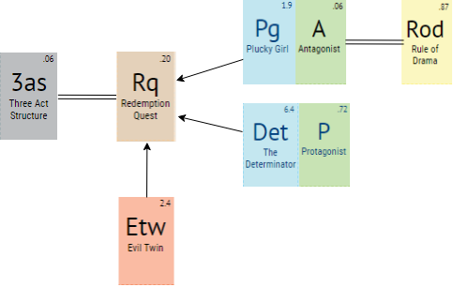

**Figure 1.** *Periodic Table of Storytelling*

# Concepts

## Game Analysis

This is single player adventure game which consists of a linear story with the main characters Sophie and Calcifer. Also, there are an enemy, a demon, a princess, and a king. The game duration is approximately 1 hour. The development platform is PC. The camera is third person. It acts as the player's eyes, letting them see the game world from different points of view. Since it is a Unity game, a 3D camera works just like a film camera. It can be panned, tilted, and zoomed to frame scenes.

## Project Setup

We need a simple project to test our camera scripts in. We'll need a scene with a ground plane that has a texture on it. This will make it easy to see how each camera moves and reacts to player inputs. All the cameras we're going to create will need a target: something to look at or follow. Additionally, we want to use The Dungeon Crawler Camera and the Follow Camera. The Dungeon is the type of camera you would typically find in games like Diablo, also known as a "dungeon crawler" game. The camera sits above the player and moves relative to the character, but never rotating. Instead, the follow camera is commonly used in platforming games like Mario Galaxy. The camera sits behind and above the player and rotates around the character as they turn. Since we use more than one camera, we want to use all of these as a one camera. In other words, more than one camera script can be applied to a single camera at the same time.

To switch between the different scripts, enable the script you want by checking it and unchecking all the others. This could be useful for switching to a different camera style for establishing shots or cut scenes. Shortly, Unity comes with several camera scripts. The scripts are well documented, easy to customize and make great guides for building and improving your own camera scripts. Because of all these reasons, we preferred to use Unity Game Engine. With the help of Unity, everything will be easy to build a wide variety of cameras for any type of game. With just a few lines of code, the most important element in the game is ready to go. While some may find the math a little intimidating, Unity provides so many useful convenience functions that most of the heavy calculations are already done for user.

## Platform

It will be at windows platform, so that you will be able to download from Windows Store.

## Functionality

These are stunning graphics and environments, skill system, experience system, in-game shop and daily reward.

## Target Audience

This is the adventure game for teenagers.

## Player’s Skills and Interaction Ways

**The player can:**

* Move the character controlling, left-clicking on the screen or using **WASD**
* Interact with objects or characters by left-clicking on them
* Open the phone’s interface using the proper key: **F**
* Possible actions inside the phone’s menu:
  + Navigating it using the mouse or **WASD**
  + Selecting functions using mouse left-click, **ENTER** key
  + Exiting the phone’s menu using **ESC** key or **F** key
* Functions of the phone’s interface (each submenu will be shown in a similar way to the main menu, with small icons, longer menu will have a scroll bar on the right to navigate it):
  + Sound playback:

Allows to listen to recorded sounds

* + Watch photos and videos:

Allows to watch photos and video taken

* Diary:

The player can save her/his progresses though the game and read a resume of the precedent events.

* Tablets or other readings resume:

The phone remembers perfectly what the player read, so it is possible to read everything again

* Switching characters using **TAB** key.
* Pressing **Q** to select an object through a classic circular menu. The selected object will be displayed on the right bottom and the left click will use it on an element of the map if allowed.

**The following skills depend on which character the player is using:**

* Sophie’s & Calcifer’s skills (selectable through a circular menu, triggered using the **R** key):
  + Taking photos or videos (right-click)
  + Recording sounds (right-click)
  + Hyper scan: right-click on objects to scan them and store them into the phone (required to combine that ingredients to craft objects)
* Torch (right-click to turn off/on)
* **Stealing:** she can lock pick doors or pickpocket people (right-click to specific targets).
* **Killing:** when allowed, she and he can kill NPCs (when available, right-click on the targets).
* **Acrobatics:** there are high walls or narrow passages that he and she can pass (right click on the targets).

To sum up, you can switch the character whenever you want, but when you want to fight with Girolamo or against obstacles, then you can use both 2 characters with the help of the **F1** button. In this way, you can defeat the enemy.

# Game Settings

In this game, there is an enemy, a demon, a princess, and a king apart from Sophie, Calcifer and Howl. The story is set in the magical land called The Forgotten Florence, similar a land of Italy, a place where is significant in the Renaissance, Florence. Mario di Magnifico is in love with Florence that’s why he created this land that full of magical power. Thus, technology has not developed yet, you will use primitive things to fight. Some places in the Forgotten Florence, and of course Howl’s Moving Castle are the places where the characters most often are.

The relationship between the Forgotten Florence and the Moving Castle is Howl. Howl is kidnapped by an Italian magician so that the new color appeared on the sector with the act of Zeppy. In this way, the door is opened to Florence. You will visit different places in Forgotten Florence according to the order in the word diagram because you must rescue the King’s daughter life, Veronica, to find Howl himself.

## Locations

**Howl’s Moving Castle:** The Castle that Calcifer moves it by using his power. He lives here with Howl and Sophie.

**The Hatter:** A hatter where Sophie and Calcifer entered to ask questions about the magical land.

**Palazzo di Nuovo:** Marcello family lives here.

**Chapel di Amore:** This palace has been the symbol of the love of Forgotten Florence where Mario di Marcello fell in love with his wife.

**Chiesa Fiorentino:** The enemy appears in front of this church. It is surrounded by touristic palaces.

**Galleria di Angelo:** A unique location in the world that alternates perfectly restored historic art and the lost crown is hidden there.

## World Diagram

metin, harita içeren bir resim

Çok yüksek güvenilirlikle oluşturulmuş açıklama

**Figure 2.** *World Diagram of the Project*

## Goal Outline

1. **Find Howl**
   1. The new colored sector has appeared on the magic door.
      1. Try to understand where you are.
         1. Discover the new city to find Howl.
      2. Reach the hatter.
         1. Ask questions about the city and people.
            1. Hatter gossiped, and the King knew the new guests.
      3. Go to the palace of King Mario.
         1. Understand the situation of the King and themselves.
         2. Make negotiation with the King and accept the mission.
   2. Rescue the Princess life to know where Howl is.
      1. Begin the journey from Chapel di Amore.
      2. Fight with Girolamo in Chiesa Fiorentino.
      3. Go to Galleria di Angelo to look for the magical crown.
         1. Fight with evil spirits
         2. Take the help of evil twin Zeppy.
      4. Take the crown and go to Palazzo di Nuovo.
      5. Give the crown to the King.
      6. Get the letter which has information about the Howl’s place.
   3. Go to the place where Howl stays like a captive.

# Themes

The main theme of this story is **“Family & Love”**. In this adventure, all the evil is destined to be destroyed because of the love of friends. The king is trying to help his daughter which refers to family, and Sophie is trying to find her love Howl with her reliable friend and her companion Calcifer.

The second theme is **“Courage and Heroism”**. The story goes around so that Sophie will defeat all enemies and be able to save Howl which exactly defines her character of being the plucky girl.

The other theme is **“Hope & Trust”**. When Sophie felt herself like hopeless, Calcifer encouraged her with lovely words. He supplies hope for her since they have a strong relationship in that story. Also, the only chance to find her beloved is trusting to the King Mario. Otherwise, she cannot able to find Howl herself.

The last theme is **“Magic”**. Magic is seen to be pursued as a career choice rather than something that comes from within, but there are also those in whom the gift lies unbeknownst to them, and Sophie is one of these people.

# Synopsis

## Premise

Sophie is a brave and determined woman and witch. She is cursed by the witch of the Waste and left home and set off through the countryside. She started to live Howl’s Moving Castle with Howl, and Calcifer luck into something for a long time. She was in love with Howl, a powerful wizard, before she cursed. The Moving Castle is with a magic door that allows to reach other places in the world, also in the past. By the way, she learned that Howl's life is somehow bound to Calcifer's and that Howl has been transforming into a bird-like creature to interfere. After the big war between the fictional kingdoms, Howl and Sophie turned into their own appears. In the end, all of them traveled high in the air in a new flying castle.

## Act 1- Setup

### This act take place in level 1

After Howl disappeared mysteriously, Sophie has realized to be a powerful witch, but she is still inexperienced and needs the training to master her skills. At that moment, Sophie and Calcifer who are great friends was sitting in Moving Castle. Suddenly, a new colored sector has appeared on the magic door because of Calcifer's treacherous and unaccounted sibling, Zeppy. The new color is in a magical place called “The Forgotten Florence”.

## Act 2- Confrontation

### This act take place in level 2, 3, 4 and 5

When Sophie and Calcifer started walking in the streets to understand the place and its people. They saw a hatter and asked some questions about the city. The hatter gossiped on them and the King knew that there are new guests in Forgotten Florence, and one of them is a witch, and the other is a demon. He evocated them into the palace and give them a mission to rescue her daughter’s life. In return, King promised to find Howl. The mission is finding the crown. In this way, Princess Veronica's spirit would be saved from evil forces. This is the only way to rescue Howl, the King can find him since he is a powerful and authoritative man. Also, the King’s master enemy Girolamo trying to prevent them. Sophie and Calcifer started to look at the crown. Along the way, they ran across not only obstacles like barriers but also Girolamo, the enemy of the King.

## Act 3- Resolution

### This act take place in level 6, 3 and 1

Sophie was desperate and missed Howl so much but found the crown with the help of Calcifer’s twin in Galleria di Angelo. Zeppy was cruel. However, when he saw his twin unhappy, he found themselves contending with a good twin, and help him and his friend Sophie. Finally, they gave the crown to the King, and Mario di Magnifico gave the location of Howl in an envelope, the letter. They save both the princess and Howl. Sophie found his lover with hard effort.

# Story

## Complete Story of the Level

Sophie, Calcifer and Howl live happily together in the moving castle. Sophie has realized to be a powerful witch, yet she is still inexperienced and needs training to master her skills. One day they woke up and they did not see the Howl. But they had no idea about where he went or why did he go. They tried to find him or communicate with him. Sadly, they could not. Howl has disappeared and never came back. After that, they learned that Howl is kidnapped by an unknown Italian magician.

Sophie and Calcifer were sitting in Howl’s Castle. They were thinking that everything has been improved and good days were close enough. While they are in these positive thoughts, suddenly Calcifer has been discomforted as he has been feeling that something was walking around the castle. Suddenly, he heard the laugh of his traitor brother, Zeppy.

Four colored Wheel started to rotate automatically, and a new colored sector has appeared on the magic door. The door of the castle opened spontaneously with the huge wind effect. All the furniture started to fly. Sophie and Calcifer could not hold themselves constant at their places. They could not resist the storm despite all the efforts. Eventually, they found themselves at the middle of the storm, in Florence.

When they woke up, they found themselves among elite people, glamorous and cozy chapels, and flawless architectures. They didn't know why they were here and how they are going to go back. However, as Howl is missing for days there was a possibility that maybe he can be here. They started to discover neighborhoods to know where they are, and what the reason behind being there is. Everyone was staring at them (especially Calcifer). Kids were running away and screaming because of the Calcifer. Also, Calcifer frightened about it and don’t know what to do. They stopped in the first hatter they saw which was in Via de Tortellini. By emphasizing they are a newcomer, they started to ask some questions to the hatter. After he learned that Sophie used to be hatter also, he asked her if there is a possibility that she can work with him, as his assistant is not going to be able to work for a while. He was gazing at Calcifer while making the offer. Although he did not say it out loud, he felt that unordinary events are going to take place soon in Forgotten Florence.

This matter became quickly widespread in the city. No doubt, the king’s family were already aware of the matter as well. They seemed like they were busy with their newly established bank, but King Mario had a bigger trouble. Her daughter, Veronica, was physically beside him, but her soul was taken by evil forces. There was a solution, but she was not strong enough. However, when he heard that a girl name Sophie arrived in the city and she brought a demon with herself, he got his hopes up. Mario could not afford to keep at his castle without using their power. It was about his daughter this time. He immediately summoned Sophie and her companions into his castle.

When Sophie and Calcifer arrived, they denied they had an extraordinary power. However, with an offer from the King, everything changed. When the king heard that Sophie and Calcifer had come to find the wizard named Howl, he said that if they could help him to find the object needed for his daughter, he could learn the location of Howl. By the way, the King lost all his power because of creating the Forgotten Florence. Because of that, he needs the help of Sophie and Calcifer. Though Sophie just started to use her power, she accepted the deal by trusting Calcifer.

The object that they are going to look for was a crown, the “Crown of Beauty”. It has colorful stones with different size, and it was gifted to Veronica one year ago. She would be able to free her soul from evil forces and return to life by using this crown. Because when she captured by the evil, she wearied this crown. After that, her soul went with the evil, and the crown disappeared magically. For that reason, the King was thinking that if Veronica can wear the crown again, she will have her soul. Because of this reason, King offered an accord. While they were looking for the crown, the King would do what he could for finding Howl, and then give the location of Howl to Sophie and Calcifer. However, there was a big problem. The crown could be anywhere in Forgotten Florence. Moreover, that was not the only problem. Mario di Magnifico’s enemy, Girolamo also wanted to find it. Girolamo wanted the crown for himself because he was thinking that the crown was going to empower him. King Mario’s family were aware of the matter and they were also aware that he couldn’t yet found it. That is why Sophie and Calcifer duty was going to be hard. They found themselves in front of Chapel di Amore without knowing where to start. This place was outside the city walls. When they were thinking about what to do, Girolamo had learned everything. As Girolamo wants to find the crown more than anything, he planned some evils plans to stop Sophie and Calcifer on their journey.

Sophie and Calcifer wasted a lot of time in Chapel di Amore. While passing through Chiesa Fiorentino, the came across with Girolamo. They tried to prevent Girolamo by putting their power together. In this period Sophie’s soul got hurt. When Calcifer saw the condition of his closest friend, he did his best and defeated Girolamo. After that, he shared his power with Sophie and they moved forward Galleria di Angelo. For some period, Girolamo couldn't block their way, but even though he was far from them. He continued to make obstacles for them. Supernatural beings surrounded Sophie and Calcifer in Galleria di Angelo.

Sophie was so desperate. She started to think nothing is going to recover and they are not going to find Howl. While she was in misery, she heard Calcifer’s voice at a distance. However, the one who was talking was not Calcifer, in fact, it was his twin brother Zeppy. At that moment, everything became clear for Calcifer. The one who has turned the wheel was his sibling. But why was he here right now? Would he help them? While Calcifer was thinking about those things, Zeppy moved and destroyed all obstacles in front of him with his special powers. While he was thinking of getting out, Zeppy moved in a different direction. Calcifer wanted to thank him, so he went after him. Zeppy was in front of a well. He went to near to a chest and came back a little later. He had a crown with a lot of valuable stones. Brothers glanced to each other for a moment. Zeppy told them that they should take the crown and go away because Girolamo could block them again, and he gave the crown to the Sophie.

Sophie came back to the Palazzo di Nuovo with Calcifer. She handed the crown to Mario. Mario didn't want to give the letter before putting on the crown on his daughter’s head. The king ran into Veronica's room. As soon as the crown was put on her head, she came back to life. She started to breathe, she survived. After that, Mario give the letter to them. He found where Howl is; however, he said that they could not save him. This was not a problem for Sophie and Calcifer. Nobody could spoil their mood now. Regardless of her being a witch, she was not killed and the idea of her being together with Howl made her excited. They opened the envelope and took the paper inside it. Howl is at “Fire Island” which is an island near the Forgotten Florence. Afterwards, they arrived in the Moving Castle with Howl’s impressive magical power. It was faster than everything. But this adventure was not enough for them. They started to prepare for a new legacy. Sophie and Calcifer even happier than before…

## Dialogues on the Level

**In Galleria di Angelo: add score and ambient sounds**

**>>** Sophie fell to the ground.

*drop voice*

**Sophie:** Calcifer, my friend, I do not want to give up, but I do not have any strength.

**Calcifer:** Stay with me Sophie, I am more powerful with you. You feel like me that there is no place like our castle, with Howl. Thus, we must find Howl. Prepare to win.

**Sophie:** I am always with you Calcifer, do not worry.

**Calcifer:** Support me with your power.

**Sophie:** I am not a powerful witch Calcifer…

*sigh*

**Calcifer:** I do not want to survive Sophie. I just want to live with you and Howl.

**Sophie:** I know that you make me want to be a better witch. Let’s fight my little friend.

**>>** Sophie stands up and walk over to the obstacles...

**In Palazzo di Nuovo, after finding the magical crown:**

**>>** Sophie has entered to the hall while running. She gave the crown to the King and waited for the information about Howl. She was very excited. However, …

**King:** Wait for me here. Firstly, I should go to my daughter.

**>>** He left the hall. After a while he came back. He looks like very happy.

**King:** I very appreciate meeting with you guys.

**Calcifer:** Also, us…

**King:** Now, my daughter woke up, and told me “father” after one month. Love means never giving up.

**Sophie:** I understand you sir…

*sigh*

**King:** You love Howl very much, Sophie. I can see this in your eyes.

**>>** Sophie cries quietly

**Sophie:** Could you find his place?

**>>** She asked curiously

**King:** Yes, I could. I will give you the rotation. Before that, I want to say something to you… When you realize you want to spend the rest of your life with a man, you want the rest of your life to start as soon as possible.

**>>** Calcifer filled with tears.

**Sophie:** We will rescue him as soon as possible. Howl is everything of me.

**King:** (give the route) – Now, you are free. I wish I knew how I can help you. But, this is what I can. You are alone in this new adventure, goodbye…

**>>** Sophie and Calcifer left the room…

# Characters

## Sophie Hatter

### Description

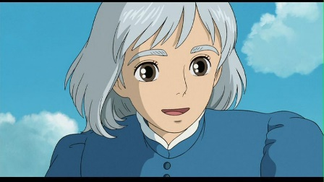The story is centered on Sophie Hatter. She is a young woman who is eighteen years old. She was living in the land of Ingary. She has brown eyes and brown long hair. Before she met a wizard, Howl, she was shy and unconfident. With the curse of Witch of the Waste, she looked like an old woman with her gray short hair. However, one thing did not change which is herself. She is still an optimist, charitable and friendly with the help of her good heart. Now, she is living with her best friend Calcifer in a moving castle with her disappeared love, Howl.

### Backstory

Sophie was the eldest daughter of her family, and she lives a boring life by working as a hatter in a small magical kingdom of Ingary with her father and her step-mother. She was working in her late father's hat shop, when her father died. Due to Howl who is the man that Sophie fell in love, she is cursed by the Witch of the Waste. Sophie leaves her friends, her step-mother, her hometown and the hat shop to find a cure without anyone seeing and recognizing her. Then, Sophie became not only an old woman but also a brave and adventurous woman. Because of her new appearance, she left her home and the hat store. She found moving castle with the help of something spiritual. While she was living with Howl and Calcifer, she fell in love with Howl, and the curse started to break with this powerful love.

### Circumflex and Relationship Map

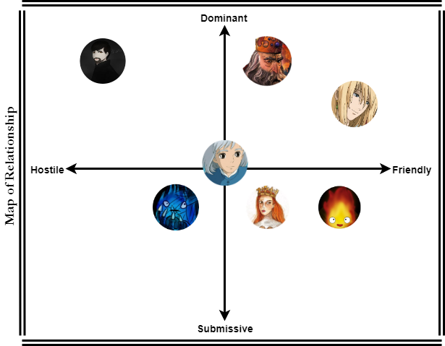

**Figure 3.** *Circumflex of Sophie Hatter* **Figure 4.** *Relationship Map of Sophie Hatter*

## Calcifer

### Description

iç mekan, bakarken içeren bir resim

Yüksek güvenilirlikle oluşturulmuş açıklamaCalcifer is the fire demon that helps Howl to move his famous castle and with other errands in the castle during the movie and in the novel. It is the mix of red, orange and yellow. He has tiny licks of flame that serve as arms. After Sophie moved into the castle they became friends and ran to adventures together, saved Howl’s life, since Calcifer is a good demon. He eats wooden logs as a meal. Since he looks like a fire, he afraid of the water. Besides he is a very powerful creature himself, with a great deal of magical ability. Moreover, he can move around by floating in the air. As he is a demon, he cannot be trustable. His humor is different than the other characters such as he can keep information from others even if it is a useful information. Despite everything, Calcifer still continues to help Howl and Sophie.

### Backstory

He has been with Howl at the Moving Castle since their deal. Calcifer was a star, and he fell in Howl’s hand before he could fall to earth and disappear it. At that moment Howl and Calcifer made a magical contract. According to that, the fire demon agreed to help Howl to heat him and move the Howl’s Castle. Calcifer lived for many years in Howl’s moving castle. One day, a new person came the home who is Sophie. They became extremely close, especially after Howl left them. He promised to Howl to use his magic to break the curse on Sophie. He has chosen to stay with Howl even though the contract has been broken.

### Circumflex and Relationship Map

### 

**Figure 5.** *Circumflex of Calcifer* **Figure 6.** *Relationship Map of Calcifer*

## Howl

### Description

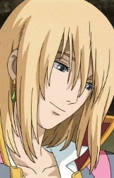

Howl is a wizard. His appearance in the movie is changing continuously. Howl has shoulder-length straight light blonde hair. He has light blue eyes. He is tall and slim. He gave a lot of importance to his appearance. We can understand this when Sophie cleaned his bathroom and mixed some hair potions. Howl is also a very kind wizard. He made good magic. Moreover, he is good-hearted and charitable with Calcifer and Sophie. For example, he allows them to live with him in his moving castle, always trying to protect them from any danger since he loves them very much and is very forgiving of their mistakes.

### Backstory

He gifted with a natural talent for magic, he began studying it and became a clever wizard. One night, Howl caught a falling star called Calcifer and made a contract with him. He gave his heart to the creature, binding them together, and allowing Calcifer to live his castle. During this time, Howl courted and then dumped the Witch of the Waste, who put a curse on him. Howl infrequently did work for the King's army but avoided meeting with them as much as possible. Then, he met with Sophie when he rescued her from soldiers. Because of this incident, Sophie cursed and with the help of something spiritual, Sophie started to live with Howl and Calcifer until Howl disappeared…

### Circumflex and Relationship Map

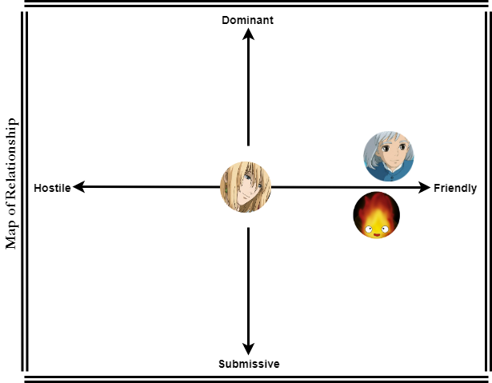

**Figure 7.** *Circumflex of Howl* **Figure 8.** *Relationship Map of Howl*

## The King Mario di Marcello

### **https://lh5.googleusercontent.com/eX4Oyzcag488RHlEh58l1b7CvLF6URoSPZWQeuLmo36gKUoZmrU5xbrotU3J1FRiKnMJQOcBHVIRmOzF95CSXfdEmK_3EC-CmM0q1CFWTkDAs5xJGscIBNohQpuKN2YslhHHNmct**Description

He is also called Magnificent Mario. The King of the Forgotten Florence is trying to save his daughter. He is extremely alone on his throne and desperately missing his family. He doesn’t have any superpowers anymore, all he has is his wisdom and his army. Besides these problems, he can stay powerful. Although his face was not handsome it was as full of dignity as to compel respect. Mario was described as rather plain of appearance and of average height, having a broad frame and long legs, shoulder-length wavy gray hairs and green eyes, a squashed nose, short-sighted eyes, and a harsh voice. He created the Forgotten Florence inspired by the real Renaissance city “Florence” before he lost his powers. But now, he seeks the crown for his only daughter.

### Backstory

Mario considered the most promising of the five children of Piero and Lucrezia. With his brother Giuliano, he participated in jousting, hawking, hunting, and horse breeding. For these a lot of children, he became the King. He is the ruler of Florence, in his big war against dark magic he lost his wife, and now his daughter became a captive of a dark spirit. He is desperately trying to rescue his daughter and trying to find the magical crown which can save his daughter.

### metin, harita içeren bir resim Çok yüksek güvenilirlikle oluşturulmuş açıklamaCircumplex and Relationship Map

**fotoğraf içeren bir resim

Yüksek güvenilirlikle oluşturulmuş açıklama**

**Figure 9.** *Circumplex of Mario di Marcello* **Figure 10.** *Relationship Map of the King*

## Girolamo Riario-The Enemy

### kıyafet içeren bir resim Çok yüksek güvenilirlikle oluşturulmuş açıklamaDescription

Girolamo Riario is the Lord of Imola and Forlì, and a member of the Templar Order. He is the master knight of the dark knights. He is just trying to find the source of dark magic that some people are cursed and looking for. He is really an egoistic man but in addition to that, his soldiers listen to him every time. He is a senior knight also he is strong and master on using the two-handed sword. The most important characteristic of this man is that he is never giving up. He wants the crown and become a more powerful man. Apart from that, he is a father. He is tall and slim. He has dark short hairs and brown eyes. Moreover, he has muscled body.

### Backstory

Riario secured his power early in life using his connections to the church. He was married to Caterina Sforza, daughter of Galeazzo Maria Sforza, the Duke of Milan. The couple resided in Rome during Sixtus' pontificate, where Riario gained a reputation for being one of the most ruthless nobles at court. After that, Riario secured the titles of Lord of Imola and Forlì.Girolamo is with the king since he is a little boy, his extreme hunger for power brought him success and he became the head of the king’s knights. He admires dark magic, he believes that he can become superior with dark magic. During events, Riario became a prominent enemy of Mario di Magnifico, leader of the Forgotten Florence, and seek for the magical crown to have more power.

### metin, harita içeren bir resim Çok yüksek güvenilirlikle oluşturulmuş açıklamaCircumflex and Relationship Map

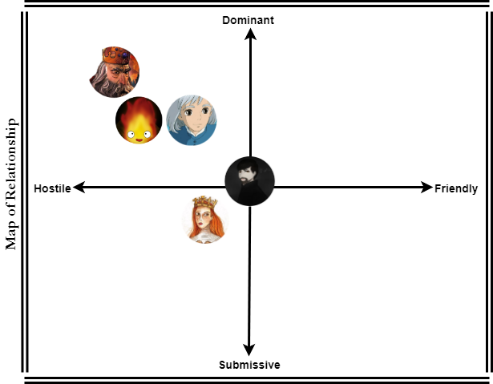

**Figure 11.** *Circumflex of Girolamo* **Figure 12.** *Relationship Map of Girolamo*

## Zeppy – The Evil Twin

### Description

**iç mekan, duvar, tablo, yer içeren bir resim

Çok yüksek güvenilirlikle oluşturulmuş açıklama**The ghost is the twin of Calcifer. No-one can see him except Calcifer. He is a snow demon which can freeze everything. Also, it can fly. It is usually getting bored so want to have fun. Also, it is understanding of fun is making trouble to someone, especially to Calcifer. Because of this, our character “Zeppy” suddenly appears in the tale of our main characters. For example; it turns the wheel while laughing at Calcifer in a mad way and starts our characters adventure. On the contrary, he helped Calcifer and Sophie, when they had in terrible.

### Backstory

Zeppy is the lost sibling (twin) of Calcifer. It born from the void. It is annoying, mad, and arrogant and the most important thing about it is a big trouble-maker. When Calcifer fell in Howl’s hand before he could fall to earth and disappear it, Zeppy lost his sibling and he could not find him anymore. One day, he saw the Moving Castle and he could not understand how it can move without any magic. Suddenly, he thought that maybe Calcifer moves that castle and check its inside. After that, he saw Calcifer on the woods. He was angry at him. Because of this, he turned something on the door to change their places. However, he used his power and the sector stopped a place where is created by an old magician. It was a magical land, the Forgotten Florence.

### Circumflex and Relationship Map

**nesne içeren bir resim

Yüksek güvenilirlikle oluşturulmuş açıklama**

**Figure 13.** *Circumflex of Zeppy* **Figure 14.** *Relationship Map of Zeppy*

## The Princess Veronica

### Description

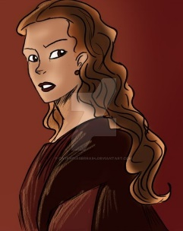

Veronica is the daughter of the king and her body is possessed by a bad spirit, this spirit uses her body to make her dad (The King) suffer. King needs the magical crown to be able to rescue his daughter’s body from the spirit. She is a very beautiful young woman. All the dukes and princes admire her. They ache to marry her. She has long orange hairs and dark green eyes. She is neither tall nor short. She is clever and charming.

### Backstory

She is an Italian noblewoman. After her father’s relentless war against dark magic, her body is possessed by a spirit. Before this extremely sad situation, she was living happily with her father and mother. Before she cursed, he was about to marry with a rich French Prince. When she lost her spirit, he gave up from marrying. In this way, the King promised that when her daughter woke up, she will not marry with this man.

### harita, metin içeren bir resim Çok yüksek güvenilirlikle oluşturulmuş açıklamaCircumflex and Relationship Map

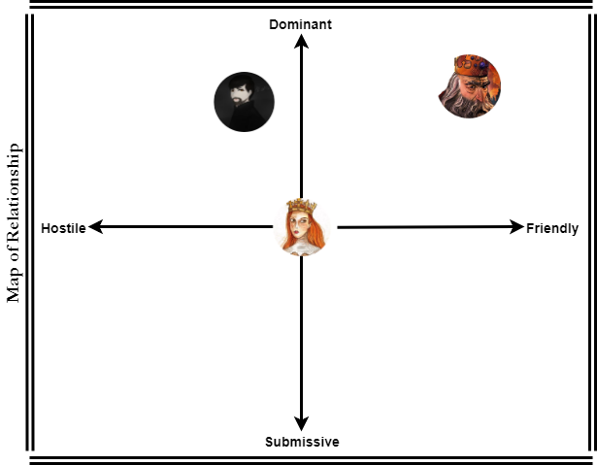

**Figure 15.** *Circumflex of Veronica* **Figure 16.** *Relationship Map of the Princess*

## Interpersonal Circumflex

cihaz içeren bir resim

Yüksek güvenilirlikle oluşturulmuş açıklama

**Figure 17.** *Interpersonal Circumflex of All Characters*

## Relationship Table

|  |  |  |  |  |  |  |  |
| --- | --- | --- | --- | --- | --- | --- | --- |
|  | Sophie | Calcifer | Howl | King Mario | Girolamo | Zeppy | Veronica |
| Sophie |  | **friend** | **love** | **know** | **enemy** | **-** | **know** |
| Calcifer | **friend** |  | **friend** | **know** | **enemy** | **brother** | **know** |
| Howl | **love** | **friend** |  | **-** | **-** | **-** | **-** |
| King Mario | **know** | **know** | **-** |  | **enemy** | **-** | **father** |
| Girolamo | **enemy** | **enemy** | **-** | **enemy** |  | **-** | **old friend** |
| Zeppy | **-** | **brother** | **-** | **-** | **-** |  | **-** |
| Veronica | **-** | **-** | **-** | **daughter** | **old friend** | **-** |  |

**Table 7.** *Relationship Table*

# Detailed Level Description

## harita, metin içeren bir resim Çok yüksek güvenilirlikle oluşturulmuş açıklamaLevel Flowchart

**Figure 18.** *Basic Flowchart of the Story*

## Event Diagram

Those diagrams show:

**Time:** ideal time that the player needs to complete this part

**Impact:** emotional impact of story in this point

Number and colors indicate different kind of action/interaction:

ekran görüntüsü, sabit içeren bir resim

Yüksek güvenilirlikle oluşturulmuş açıklama

**Figure 19.** *Event Diagram for Both Sophie and Calcifer Path*

Player will spend more time in the Fight of Girolamo and fight with obstacles. Since in the obstacles part contains also puzzle part. You can see below where each character appears (in which level), and how much time spend there (percentages):

|  |  |  |  |  |  |  |
| --- | --- | --- | --- | --- | --- | --- |
| *Chars/GameLevel* | *1st Level* | *2nd Level* | *3rd Level* | *4th Level* | *5th Level* | *6th Level* |
| *Sophie* | *x* | *x* | *x* | *x* | *x* | *x* |
| *Calcifer* | *x* | *x* | *x* | *x* | *x* | *x* |
| *Zeppy* |  |  |  |  |  | *x* |
| *Girolamo* |  |  |  |  | *x* |  |
|  | *15% of the game* | *15% of the game* | *15% of the game* | *20% of the game* | *15% of the game* | *20% of the game* |

**Table 9.** *Level Progression*

## Documents Level

* **Ideas:** For each area, we assigned some basic ideas or requirements, so that we have a short list that tells us the structure of our level. We will show that in the content segment.

Areas are connected to each other (link them) in a physical place. It gives us a foundation for understanding the basic flow of my new level at a glance.

* **Size:** It will be a single player game. Therefore, we will design multiple focal points using architectural structures, landscape elements, lighting that help the player to travel from one location point to another.
* **Progression:** For our level, we decided that the challenges should not be too hard. According to our researches, we realized that there a lot of fun of “Howl’s Moving Castle” who has under 18 (ages). So that, that level will be easy to play for our player.
* **Amount of content per area:** For our level, the areas’ description is below:

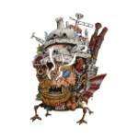

**Howl’s Moving Castle:** Start of the level; safe—no enemies. However, Zeppy looks like an enemy in this area, in contrast, he is not.

1



**The Hatter:** The path behind us closes off somehow to the Moving Castle.

2



**Palazzo di Nuovo:** When you came a second time here, you can go to directly the Moving Castle to go to Howl.

3

**\\unicloudidattica.local\share\Home\simge.haksal\Downloads\Untitled Diagram (3).png**

**Chapel di Amore:** The closest path to the Palazzo di Vecchio. It is a good idea to seek the crown here.

4



**Chiesa Fiorentino:** One encounter with Girolamo, the enemy.

5



**Galleria di Angelo:** A vertical fight against enemies; obstacles which are stones. We need a one-way exit back to the palace.

6

*This is the simple map version of the World Diagram. Our map is surrounded by different types of trees. Every rectangle represents another place which you can find the detailed information in the area description part.*

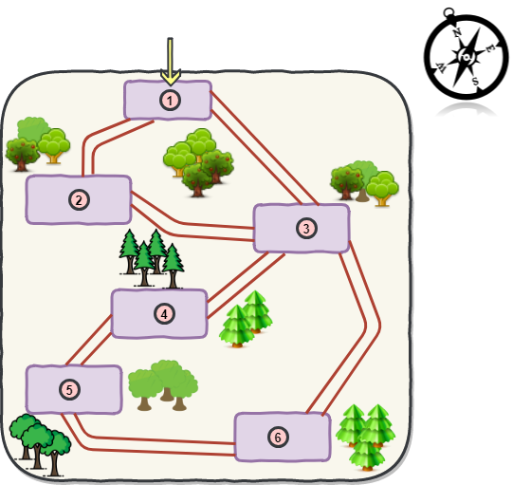The first area is of course Howl’s Moving Castle. This is the very first area of the level, it starts with Sophie and Calcifer, and Howl is just kidnapped outside the castle by the Italian magician. The castle is safe, there is no enemies inside there. However, Zeppy enters to the home by using his magical power and everything is change. He cannot damage anyone but makes something bad which will convert into good thing. Sophie and Calcifer are talking near the table. This area is 9m wide and 20m long.

Before something happened, the castle was near the river between flowers so that the sound is pipe. Also, you can hear the river at the background.

**Figure 20.** *Small Map*

## Area Description

### Howl’s Moving Castle

#### Inside the Castle

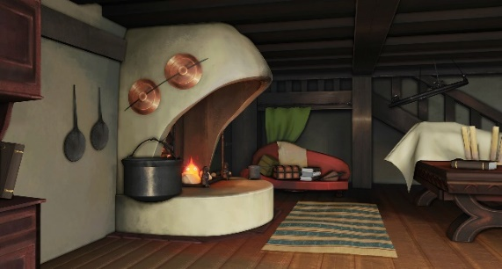

This is the living room of the Howl’s Moving Castle. This room is a place where visitors only stay. Also, Calcifer appears continuously in this room before this new adventure. In this way, he moves the castle. Furthermore, he supplies the warm water for the castle, and Sophie can cook by using Calcifer’s fire.

**Figure 21.** *Living Room of the Moving Castle*

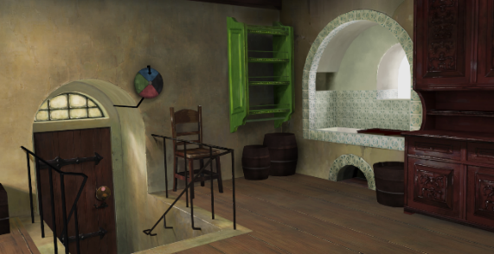This is the entrance of the Moving Castle. It is linked with the living room. You can clearly see that there is a small circle near the doorknob, and where the door leads to when opened depends on what color the circle is turned to. This allows the residents to jump many miles nearly instantly.

**Figure 22.** *Entrance of the Moving Castle*

|  |  |  |  |
| --- | --- | --- | --- |
| In the Book | | In the Movie | |
| *Before the Move* | ***After the Move*** | ***Before the Move*** | ***After the Move*** |
| Green:  The Chipping Valley | Purple:  The Waste Garden | Green: The Waste | Green: The Waste |
| Red: Kingsbury | Orange: Chipping Manor | Red: Kingsbury | Pink: Howl’s Garden |
| Blue: Porthaven | Yellow: | Blue: Porthaven | Yellow: Market Chipping |
| Black: Wales | Black: Wales | Black: Howl’s Portal | Black: Howl’s Portal |



**Table 8.** *Relationship Table* **[7]**

In our level, the hook is turned by the evil twin Zeppy randomly. However, every place changed with this turning. Then, the hook stopped on the black sector, and the door is opened to the Forgotten Florence. Sophie and Calcifer are forced to exit the Moving Castle. They thought that this is the destiny to find Howl’s new place, and the new adventure starts…

#### Outside the Castle

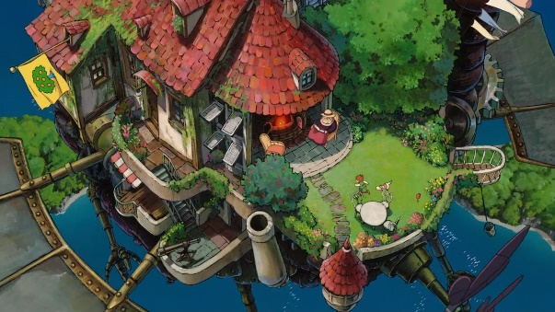While the castle is moving with the power of Calcifer, Sophie can see the outside by sitting at the balcony. Besides the balcony, there are more important things which are three “doors”. However, two of these doors cannot be approached at all, as though there was an invisible barrier blocking the way. Only the third door can be reached, which although is the back door of the castle, is the front door of the house within **[2]**.

**Figure 23.** *The Balcony of the Moving Castle*

### The Hatter

It is not a special hatter. It is the nearest hater to the Moving Castle. The owner of the hatter is a woman who likes gossiping. After Sophie and Calcifer quitted from the hatter, she told everybody that there are two new guests in the Forgotten Florence. One of them is a small demon and the other is a wizard. After that, events occur, and the King invited the new guests.

**Figure 24.** *The Hatter*

### iç mekan, tablo içeren bir resim Yüksek güvenilirlikle oluşturulmuş açıklamaPalazzo di Nuovo

Palazzo di Nuovo is the town hall of the Forgotten Florence. The walls in the rooms have elements that are filled with different concepts. One of them represents Saturn, the other is Venus. After the planet’s names, the rooms continue with flower’s name, and it continues like that. The King lives in “Mars” room, and Veronica sleeps in “Rose” room.

**Figure 25.** *Palazzo di Nuovo*

### Chapel di Amore

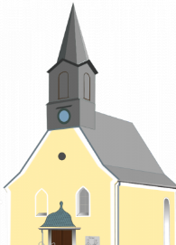

It is created by a famous architect. The chapel is located within church and gallery. However, it is not used as a chapel. It was devoted to lovers. If someone breaks up his/her partner, he/she comes there, and prays to one together again. Sophie and Calcifer seeks the crown there since it is an emotional place.

**Figure 26.** *Chapel di Amore*

### C:\Users\Simge Haksal\Desktop\indir.pngChiesa Fiorentino

Chiesa Fiorentino looks like amazing with its white color. Because of the appearance Sophie and Calcifer wanted to enter the church. There is something like mysterious, and it attracted people with its beauty. It has yellow windows without motifs.

**Figure 27.** *Chiesa Fiorentino*

### Ä°lgili resimGalleria di Angelo

Galleria di Angelo is the most famous and the biggest museum of the Forgotten Florence. There are a lot of valuable artistic pictures in the highest floor of that museum. Sophie and Calcifer are blocked by obstacles which are stones. These come for killing them. However, they got over from the stones, and found the crown with the help of Zeppy at basement.

**Figure 28.** *Galleria di Angelo*

## Check Point

In Forgotten Florence, we have AutoSaved check point. In Action/Adventure games, AutoSaved check points are points where a game will automatically save the progress and restart the player upon death. Thanks to this property, the player does not need to restart the entire level over again. This reduces the frustration and tedium that is potentially felt without such a design. To sum up, Sophie and Calcifer can die just in the Fight Area in the church with Girolamo, and before reaching the actual reward in the galley by obstacles. In this way, Sophie/Calcifer will not be start the game at the beginning in the Howl’s Moving Castle and the game will not be bored.

## Detailed Area Description

### Howl’s Moving Castle

metin, harita içeren bir resim

Çok yüksek güvenilirlikle oluşturulmuş açıklama

**Figure 29.** *Howl’s Castle 3D Render*

#### Background Music

The score will be “[Victory War & Battle Music Loops Library](https://freesound.org/people/LittleRobotSoundFactory/packs/18000/)”.



loop-nothing-can-stop-progress-12.mp3

#### ekran görüntüsü içeren bir resim Çok yüksek güvenilirlikle oluşturulmuş açıklamaLighting

The Moving Castle is always artificially illuminated, the light is orange, but with some yellow shades, specifically designed to help cooking. Some natural light comes from the door, but it is very dim.

#### Mood and Colors

Everything from the 360 lights and some sunshine lights to do the cooking as easy as possible. All the internal walls are dirty white, decorated by Howl. The dominant colors are white, grey and brown for the stone tables in the living room, and brown for the furniture.

#### Level Flowchart

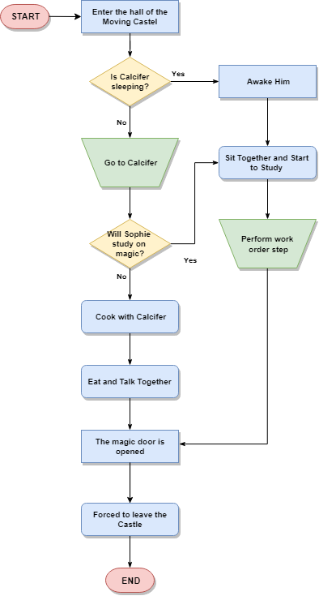

**Figure 30.** *Howl’s Moving Castel Flowchart*

### The Hatter

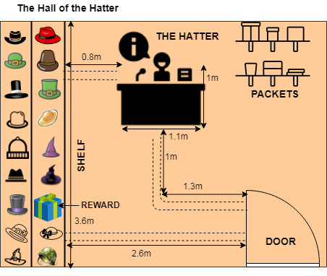

**Figure 31.** *Hatter 3D Render*

#### Background Music

The score will be “[Spieluhr / Musical Box in Lithuania](https://freesound.org/people/vollkornbrot/sounds/149974/)”.



vollkornbrot__spieluhr-musical-box-in-lithuania.mp3

#### ekran görüntüsü içeren bir resim Çok yüksek güvenilirlikle oluşturulmuş açıklamaLighting

The Hatter is always shining because of the sun, the light is yellow, but with some white shades, specifically designed to show hats. The natural light comes from the door and windows. It looks perfect.

#### Mood and Colors

Everything from the 360 lights and the clear white light is designed to give the cleanest atmosphere, intended to show hats. All the internal walls are yellow, decorated with blue classical renaissance style. The dominant colors are white and blue for the wood tables and shelfs in the hall, and brown for the furniture.

#### Level Flowchart

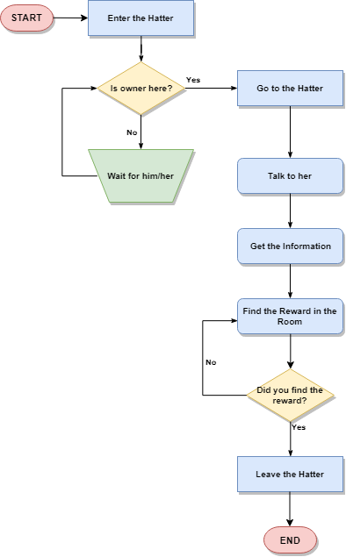

**Figure 32.** *The Hatter Flowchart*

#### Rewards in the Level

When Sophie takes this hat, she can provide herself 4 different potion just one time. These are a health potion, a corrupting potion, a hunter’s potion and a refillable potion.

#### Heath Potion



* Health Potion cannot be used at full health.
* You can use multiple Health Potions while you have one active which will queue them up to be used after the previous completes (maximum 5 stacks).

##### Corrupting Potion



* Charges cannot be used at full health.
* If the user consumes multiple charges of the Hunter's Potion at the same time, charges will queue and start as the previous one expires.
* Corrupting Potion can be used even at full health and mana.
* By consuming all three charges you can restore a total of 375 health and 225 mana.

##### Hunter’s Potion



* Charges cannot be used at full health.
* If the user consumes multiple charges of the Hunter's Potion at the same time, charges will queue and start as the previous one expires.
* By consuming all five charges you can restore a total of 300 health and 175 mana.

##### Refillable Potion



* Charges cannot be used at full health.
* If the user consumes both charges of the Refillable Potion at the same time, the second charge will queue and start as the first charge expires.
* By consuming all two charges you can restore a total of 250 health.

### Palazzo di Nuovo

metin içeren bir resim

Yüksek güvenilirlikle oluşturulmuş açıklama

**Figure 33.** *Palazzo di Nuovo 3D Render*

#### Background Music

The score will be “Queen Lure Sound”.



rhavinga_queen-lure-sound.mp3

#### ekran görüntüsü içeren bir resim Çok yüksek güvenilirlikle oluşturulmuş açıklamaLighting

Palazzo di Nuovo is a little bit dark because of the wall’s colors. The light is red. It specifically designed to show artistic paintings. The natural light comes from the windows, but it is not too much.

#### Mood and Colors

Everything from the 360 lights and the red light is designed to give the mysterious atmosphere, intended to demonstrate paintings. All the internal walls are orange, decorated with classical renaissance style with gold color. The dominant colors are red, orange, yellow and gold for the wood tables, and gold furniture.

#### Level Flowchart

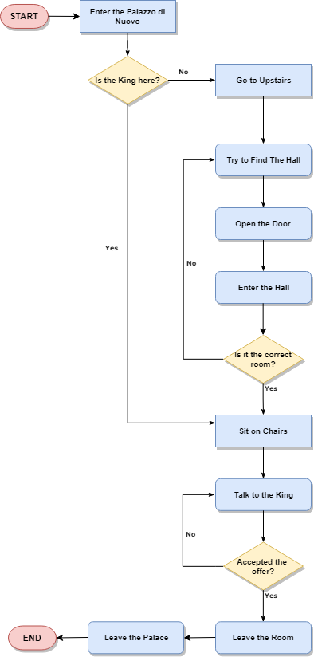

**Figure 34.** *Palazzo di Nuovo Flowchart*

### Chapel di Amore

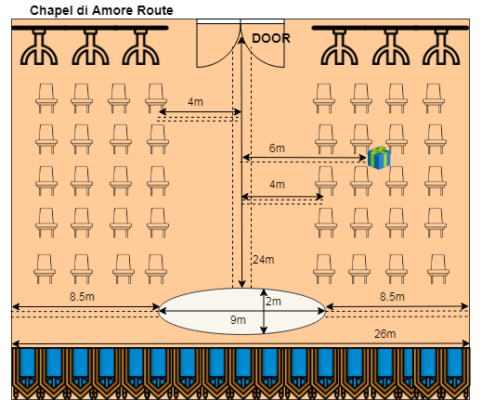

**Figure 35.** *Chapel di Amore 3D Render*

#### Background Music

The score will be “Love House and Peace”.



frankum_love-house-peace.mp3

#### Lighting

ekran görüntüsü içeren bir resim

Çok yüksek güvenilirlikle oluşturulmuş açıklamaThe chapel is always artificially illuminated, the light is violet, but with some yellow shades, specifically designed to feed lovers sprits. Some natural light comes from the door, but it is very dim. The illumination is the same as the day, with the only difference that the light coming from the door is white, because the orbs of the central hall have been turned on.

#### Mood and Colors

The chapel smells like love thanks to fresh roses. It is designed like that to give love atmosphere. All the internal walls are light purple, decorated with ancient style with gold color and blue windows. The dominant colors are pink, purple and gold for the windows decoration.

#### Level Flowchart

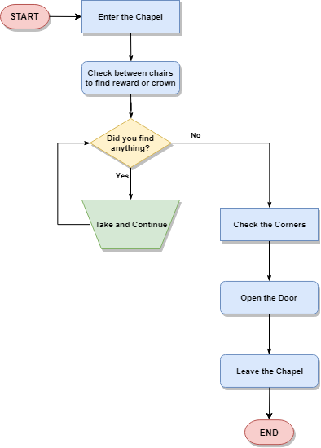

**Figure 36.** *Chapel di Amore Flowchart*

#### Rewards in the Level

kıyafet, iç mekan içeren bir resim

Yüksek güvenilirlikle oluşturulmuş açıklama

Sophie and Calcifer took a pouch of gold in the Chapel di Amore. The player can use these golds to take health and mana potion during the game. The player can use the Store to have these items.

### Chiesa Fiorentino

ekran görüntüsü içeren bir resim

Çok yüksek güvenilirlikle oluşturulmuş açıklama

**Figure 37.** *Chiesa Fiorentino 3D Render*

#### Background Music

The score will be “Choir singing Baci Coavi e Cari”.



klankbeeld_choir-singing-baci-soavi-e-cari.wav

#### Lighting

ekran görüntüsü içeren bir resim

Çok yüksek güvenilirlikle oluşturulmuş açıklamaThere are no natural lights in the church because of the windows’ style, most of the light comes from the veins along the wall. Their light is dark red and strong, there is also a blue-sky light coming from the screen but is visible only near it.

#### Mood and Colors

Here the choice of colors and materials is as historical accurate as possible, this is the place where all the higher priests live, they are natives, so the building has been built as familiar to their tastes as possible. The church is dominated with yellow and white from bricks, brown for the wooden furniture.

#### Level Flowchart

metin içeren bir resim

Çok yüksek güvenilirlikle oluşturulmuş açıklama

**Figure 38.** *Chiesa Fiorentino Flowchart*

#### Rewards in the Level

In that level, the characters fight with the enemy, Girolamo. The player can get XP in this level. Because of the fight, there is no rewards in the church except getting experience. XP helps the player progress through the level faster. When you get enough XP, you become more powerful than before in this game. If you are a wizard or magic user, you will become more powerful wizard. If you are Elf, so in this case if you play with Calcifer, you will become more powerful demon.

During the fight, if the player kills then the enemy becomes winner and the game end. However, if the player can finish this level, then s/he get XP and continue with the other level in the Galleria di Angelo.

#### Important Detail of the Level

When you enter the church, the chosen character heard the “**bell”**. The church has a rectangle shape and it surrounded by windmills. According to rumors, when all the windmills start to rotate, then nobody should enter the church because this means there is something mystic inside the church at that moment. Apart from all these rumors, there is another rumor because of these rumors. It is about secret entrance of the church. The passage in the walls was built by the ancestors and is stranded since their disappearance… However, to know this entrance or finding it, the player must turn around the church. Otherwise, s/he never find/see this entrance. If the player can find this entrance, then s/he can wait the secret area. This is the only strategy for this game. Player should think that s/he is at the 5th level and s/he did not meet Girolamo. Thus, Girolamo can appear in this level. If the player waits for the Girolamo in the secret area, and when he came to the church s/he can start to use spell directly. In this way, the player got advantage and s/he a pass the level without dying.

Let’s say that our characters do not know that they will fight with Girolamo on this area. They are starting to look at for rewards. Character pulls out the chair **(friction sound)**. Then, Girolamo appears:

***Girolamo:*** *Finally, I found you.*

***Sophie/Calcifer:*** *I was looking for you.*

…

yer, iç mekan, duvar, bina içeren bir resim

Çok yüksek güvenilirlikle oluşturulmuş açıklama

At this point, Girolamo has advantage and he starts to fight directly without giving any chance to the player (the game will force you to wait the first spell of Girolamo).

This is the only trick point of the game. You can finish the level, and the game without finding this area. But, it is a good option to wait and appear later. Then, the game force Girolamo to wait until you use your spell.

### Galleria di Angelo

harita içeren bir resim

Yüksek güvenilirlikle oluşturulmuş açıklama

**Figure 39.** *Galleria di Angelo 3D Render*

#### Background Music

The score will be “Galleria”.



sittstav_galleria-atmosphere.wav

#### ekran görüntüsü içeren bir resim Çok yüksek güvenilirlikle oluşturulmuş açıklamaLighting

During the day the Galleria di Angelo is illuminated by the sun coming from the windows. The sun is setting on the wall where the entrance is. Also, during the night the light sources are some torches placed on the wall.

#### Mood and Colors

Here the choice of colors and materials is as artistically accurate as possible, this is the place where all the paintings are belonging to famous Italian artists, so the building has been built as familiar to Italian culture. The gallery is dominated with skin color and the light also in skin color. In this way, all the halls are brilliant with full of light.

#### Level Flowchart

metin, harita içeren bir resim

Çok yüksek güvenilirlikle oluşturulmuş açıklama

**Figure 40.** *Galleria di Angelo Flowchart*

#### Solving the Puzzle

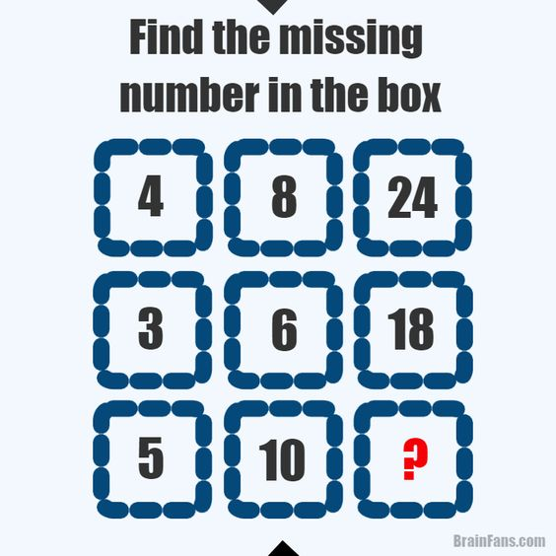

**Figure 41.** *Number Puzzle*

When this puzzle is solved by the player, player should enter the numbers into the chest. If the answer is correct, then you will find the Crown. If you could not find the solution or you found incorrectly, then Zeppy, the evil brother of Calcifer, came near to the player, and give the player the first digit of the answer. After that the player has chance to enter the new answer. If the player again failed, then Zeppy will give the last digit of the solution. In this way, eventually you will find the crown. Zeppy did this since he became a good twin in my story.

**The answer of the puzzles is below:**

Look at first row. Take the first digit and multiply by 2. You will obtain 8 which is second number of the row. Then multiply by 3 the second digit. You will obtain 24. If you check the second row, you will see the same logic. Because, when you apply this sequence for the third row. You will obtain 10*3 which is 30. If you enter “**30**” on the chest. The chest is opened magically, and the player gain the reward which I will define the next section.

#### Rewards in the Level



**Congratulations.** You will find the big reward. When you delivered the Crown to the King, you will take the Letter which includes the exact location of the Howl. In this way, you will finish the part.

### Score Map

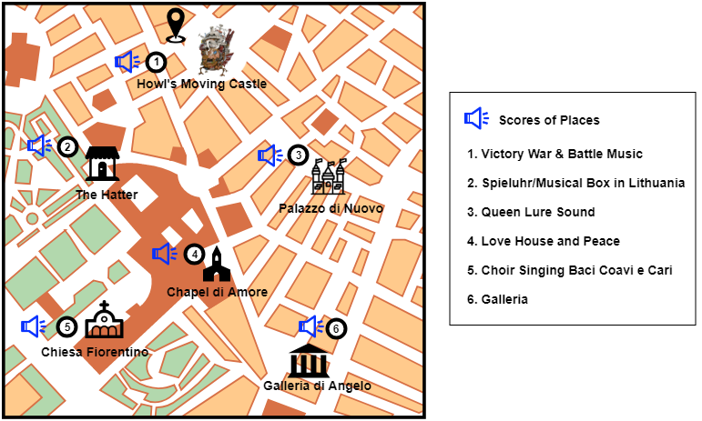

**Figure 42.** *Score of Each Location*

### Reward Map

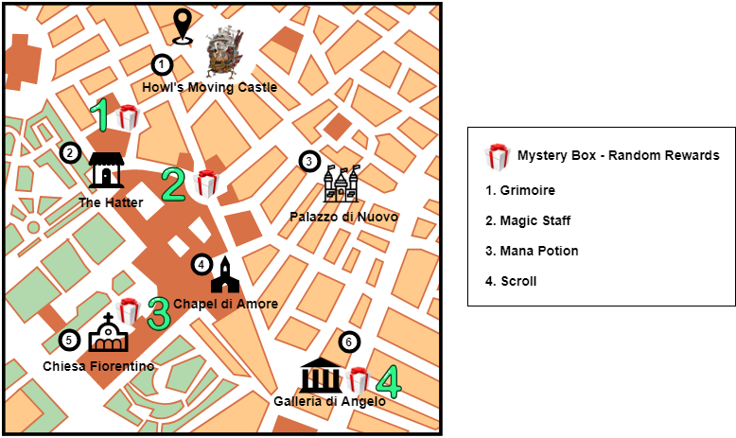

**Figure 43.** *Rewards on the Map*

#### First Reward

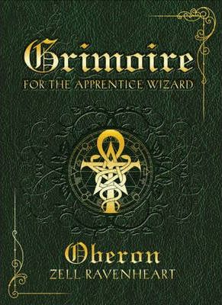The first reward is “**Grimoire**” is a textbook of [magic](https://en.wikipedia.org/wiki/Magic_(paranormal)), typically including instructions on how to create magical objects like [talismans](https://en.wikipedia.org/wiki/Talismans) and [amulets](https://en.wikipedia.org/wiki/Amulets), how to perform magical [spells](https://en.wikipedia.org/wiki/Spell_(paranormal)), [charms](https://en.wikipedia.org/wiki/Spell_(paranormal))and [divination](https://en.wikipedia.org/wiki/Divination), and how to [summon](https://en.wikipedia.org/wiki/Evocation) or [invoke](https://en.wikipedia.org/wiki/Invocation) supernatural entities such as [angels](https://en.wikipedia.org/wiki/Angel), [spirits](https://en.wikipedia.org/wiki/Spirits), [deities](https://en.wikipedia.org/wiki/Deity) and [demons](https://en.wikipedia.org/wiki/Demon). In many cases, the books themselves are believed to be imbued with magical powers, although in many cultures, other sacred texts that are not grimoires (such as the [Bible](https://en.wikipedia.org/wiki/Bible)) have been believed to have supernatural properties intrinsically.

#### Second Reward

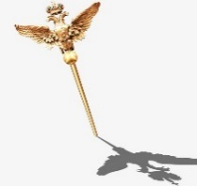Second reward is “**Magic Staff**”. A “Magic Staff” is large, thick stick of stick-shaped object usually with a medallion or amulet connected to the top. It is mostly used for its magical capabilities, but can also be wielded as a light melee weapon.

#### Third Reward

Third rewards is “**Mana Potion**”. A mana potion is an item that restores mana points, which usually allow the use of special abilities in role-playing games. Sophie and Calcifer need this potion because of the fight. Because of this, the game supply this potion as a gift for them.

#### Forth Reward

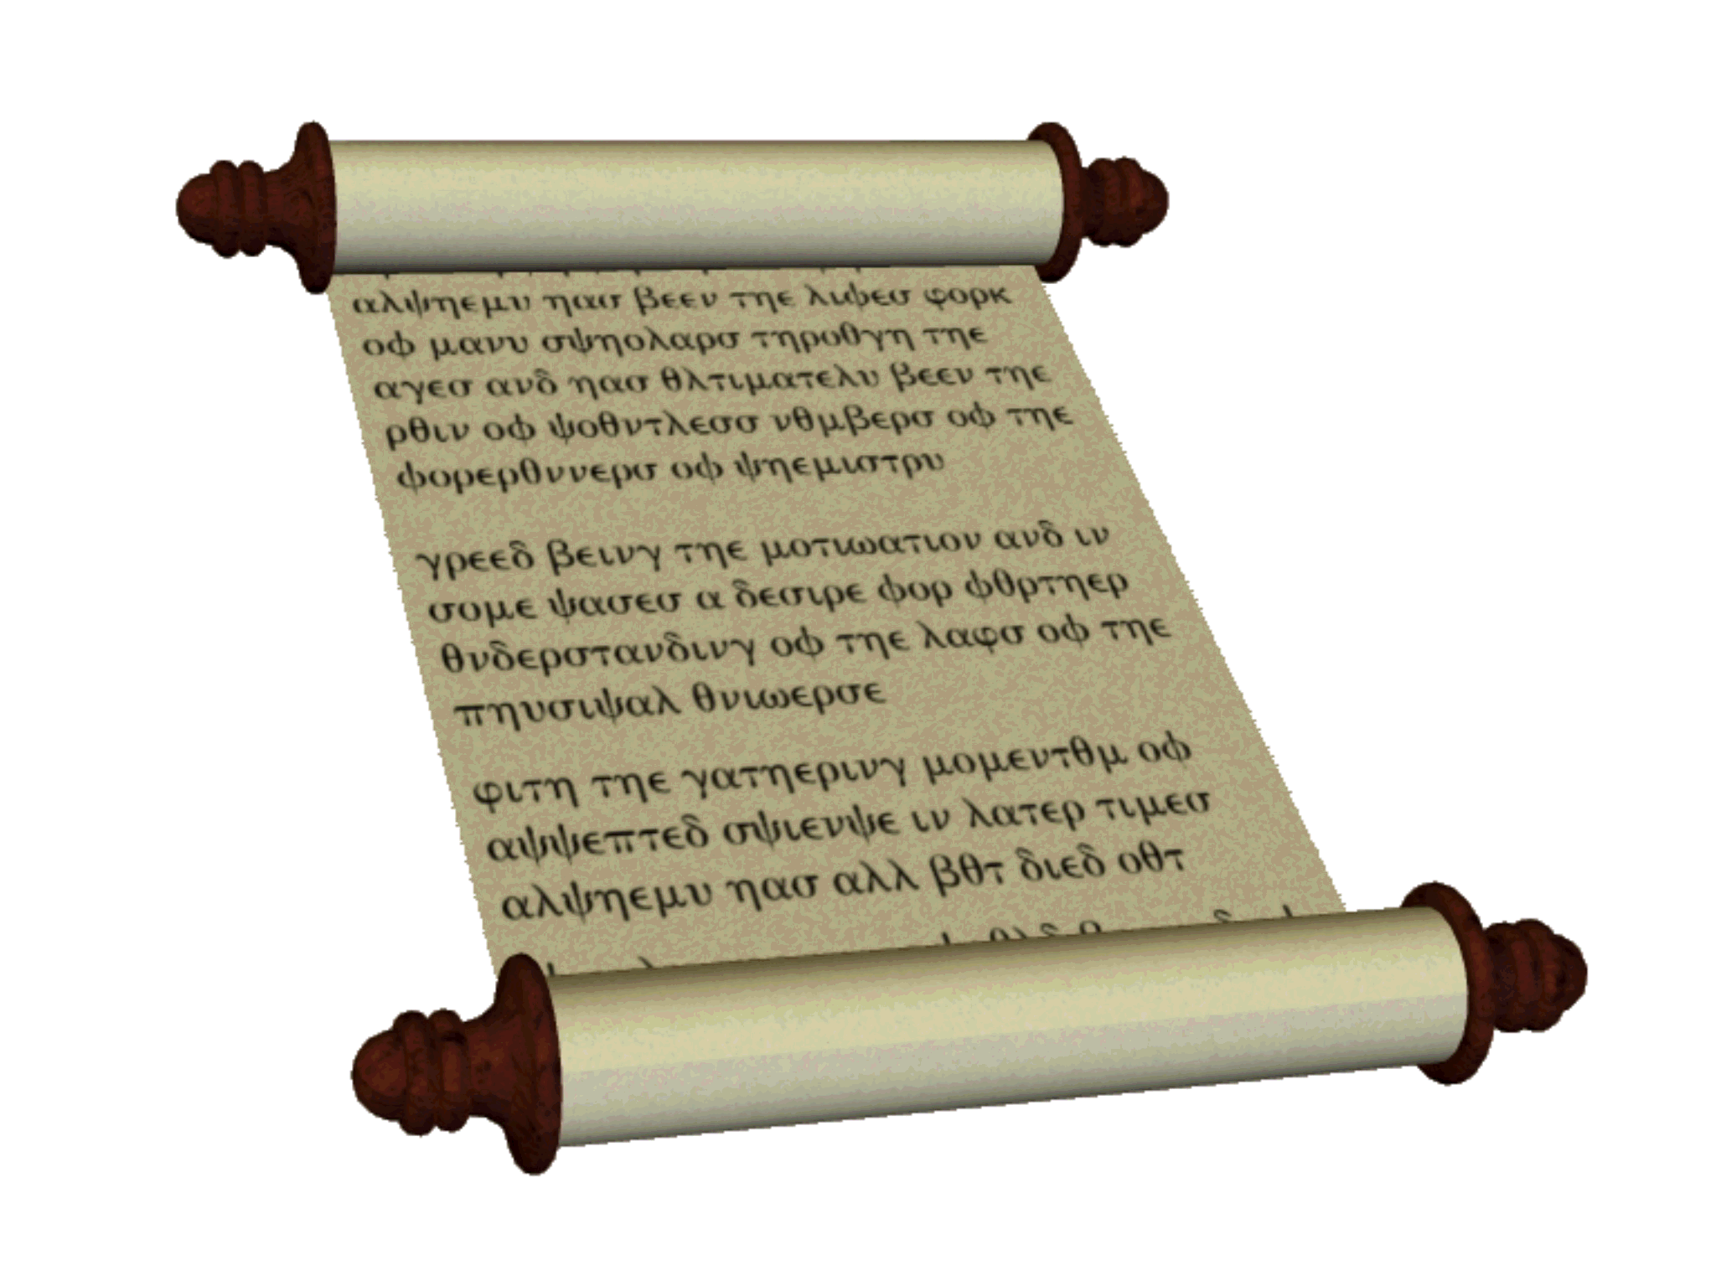 Last random reward is a “**Scroll**”. It is a roll of parchment or paper inscribed with writing, symbols, pictures etc. In our case, Sophie and Calcifer will take this as an information which says that this is the last place to visit. In this case they will understand that “The Crown” is here.

## NPCs Automata

ekran görüntüsü içeren bir resim

Yüksek güvenilirlikle oluşturulmuş açıklama

**Figure 44.** *Dialogue Puzzle*

*metin içeren bir resim

Yüksek güvenilirlikle oluşturulmuş açıklama*

**Figure 45.** *Defeat of Girolamo*

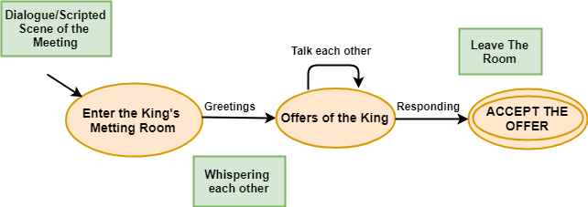

**Figure 46.** Meeting with the King

## Finite State Machine

metin, harita içeren bir resim

Çok yüksek güvenilirlikle oluşturulmuş açıklama

**Figure 47.** FSM for Collecting Items

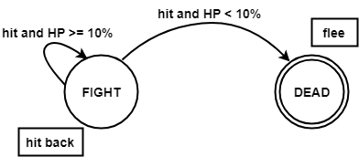

**Figure 48.** FSM for the Fight

metin, harita içeren bir resim

Çok yüksek güvenilirlikle oluşturulmuş açıklama

**Figure 49.** FSM for the Game Process

metin, harita içeren bir resim

Çok yüksek güvenilirlikle oluşturulmuş açıklama

**Figure 50.** FSM for Winning the Fight

## Measurements

### Measurement for Characters

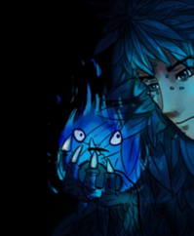  küçük resim içeren bir resim

Yüksek güvenilirlikle oluşturulmuş açıklama

**Sophie Height = 1.65m Calcifer Height = 0.30m Zeppy Height = 0.30m**

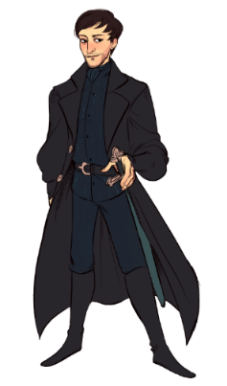

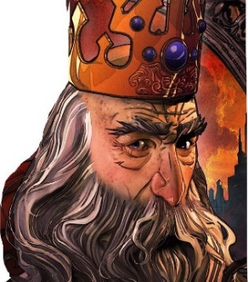

**Mario di Marcello = 1.70m Girolamo Height = 1.80m**

They are characters who actively take rolls in that level, so that the information of height is needed.

### Measurement of the Obstacles

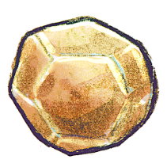 

**The Bright Rock Height = 0.70m (HP) The Wight Rock Height = 0.40m**

### Measurement of the Mission Object

 

**The Magical Crown Height = 0.20m The Letter Height = 0.10m**

## Game & Level Scope

The Forgotten Florence consists of 6 different levels. Since I am the only people in this project, I chose just one level which is the fight level with the enemy, Girolamo. This level consists of 20% of the game, and it is also most attractional level. In Chiesa Fiorentino.

## Fight Outcomes

A statistic (stat), is a number describing an aspect of a game entity. A game entity might be a monster, character, weapon or spell. Stats define game entities in the world. For the following section, we will only show the characters who have magical power. Let’s start with the characters by using these stats:

**Strength** - describes the character's physical strength. Defines the number of damage attacks inflict.

**Velocity** - represents how fast the character moves. Determines the frequency of attacks and a chance to avoid incoming attacks.

**Dexterity** - controls attack & movement speed and accuracy, as well as avoiding an opponent's attack.

**Intelligence** - represents how clever the character is. Determines the power of spells and the ability to maintain magic attacks.

**Wisdom** - frequently controls a character's ability to pick certain spells, communicate to mystical entities, or recognize other characters' motives or feelings. A measure of the character's mental resistance against pain, fear etc., when falling victim to mind-altering magic, torture, or insanity.

**Charisma** - a measure of a character's social skills, and sometimes their physical appearance.

**Health Points** - represents the amount of damage character can take before dying/being knocked out.

**Attack Type** - can be a physical attack, magical, elemental, or a combination.

**Armor Class** - derived statistic that shows how difficult to land a successful blow on char with attack.

### Main Characters Statistics

#### Sophie Hatter’s Stat

The statistics is done by using D&D First Edition.

|  |  |  |
| --- | --- | --- |
| *Sophie Hatter* | Magic-User lv.5 | |
| *Strength* | 8 | 0 |
| *Constitution* | 13 | +1 |
| *Dexterity* | 14 | 0 |
| *Intelligence* | 18 | 0 |
| *Wisdom* | 14 | 0 |
| *Charisma* | 16 | 0 |
| *TAC0* | 17 | -2 |
| *Health Point* | 24 | +5 |
| *AC* | 8 | 0 |
| *Attack Type* | Magical | |
| *Velocity* | 8km/h | |
| *Size* | Medium | |



**Table 10.** *Statistic of Sophie*

#### Calcifer’s Stat

|  |  |  |
| --- | --- | --- |
| *Calcifer* | Elf lv.6 | |
| *Strength* | 15 | +1 |
| *Constitution* | 16 | 0 |
| *Dexterity* | 12 | +1 |
| *Intelligence* | 13 | 0 |
| *Wisdom* | 14 | -1 |
| *Charisma* | 18 | 0 |
| *TAC0* | 17 | -2 |
| *Health Point* | 40 | +6 |
| *AC* | 6 | -1 |
| *Attack Type* | Magical | |
| *Velocity* | 8km/h | |
| *Size* | Small | |

**Table 11.** *Statistic of Calcifer*

#### Zeppy’s Stat

|  |  |  |
| --- | --- | --- |
| *Zeppy* | Elf lv.6 | |
| *Strength* | 15 | +1 |
| *Constitution* | 16 | 0 |
| *Dexterity* | 12 | 0 |
| *Intelligence* | 12 | 0 |
| *Wisdom* | 14 | 0 |
| *Charisma* | 18 | 0 |
| *TAC0* | 14 | -1 |
| *Health Point* | 40 | +6 |
| *AC* | 6 | 0 |
| *Attack Type* | Magical | |
| *Velocity* | 8km/h | |
| *Size* | Small | |

**Table 12.** *Statistic of Zeppy*

#### Girolamo’s (The Enemy) Stat

|  |  |
| --- | --- |
| *Girolamo Riario* | Magic User lv.5 |
| *Strength* | 0 |
| *TAC0* | 17 |
| *Health Point* | 15 |
| *AC* | 9 |
| *Attack Type* | Magical |
| *Velocity* | 8km/h |
| *Size* | Medium |
| *Dice Type* | 1d4 |

**Table 13.** *Statistic of Girolamo*

### Character’s Skills

#### Enemy’s Skills

Since Girolamo is Magic User in Level 5, like Sophie, he can use same spells with Sophie which are listed below. Moreover, I noted that spell may be cast with reverse effect when they use “Hold Monster”.

* Animate Dead
* Cloudkill
* Conjure Elemental
* Hold Monster*
* Magic Jar
* Pass-Wall
* Teleport
* Wall of Stone

#### Character’s Skills

As you can see Sophie, Calcifer and Zeppy at level 5 have obtained powerful area spells. According to D&D is “fireball”. This spell allows player to quickly resolve crashes with many enemies in tight spaces. It can be used in fight against obstacles. However, the main problem is when you use this spell, you consume a lot of MPs. By using this information, the player should use it wisely, not randomly.

|  |  |  |  |  |
| --- | --- | --- | --- | --- |
| Character | Spell Using Books | Spell by Learning | Random Effect Spells | Potion |
| Sophie | x |  |  | x |
| Calcifer |  | x |  | x |
| Zeppy |  | x | x | x |

**Table 14.** *Character’s Skill Table*

### Team’s Damage

|  |  |  |  |  |
| --- | --- | --- | --- | --- |
| Character | Damage | Computation | | Total |
| Sophie | 3d4+3 | | 7.5+3 | 10.5 |
| Calcifer | 1d10 + strength | | 5.5+2 | 7.5 |
| Zeppy | 1d10 + strength | | 5.5+2 | 7.5 |

**Table 15.** *Expected Team Damage*

### Fight against Girolamo

|  |  |  |  |  |
| --- | --- | --- | --- | --- |
| Character | Damage | Computation | | Total |
| Sophie | 3d4 | | 7.5+3 | 10.5 |
| Calcifer | 7.5 × P (1d20 ≥ 7) | | 7.5 x 0.65 | 4.875 |
| Zeppy | 7.5 × P (1d20 ≥ 7) | | 7.5 x 0.65 | 4.875 |

**Table 16.** *Expected Fight Damage*

Outcome of this computation is 7.5 + 4.875 + 4.875 = 20.25. However, in Girolamo’s fight, there are just Sophie and Calcifer so that the total damage of them is 15.375. Then, when you look at the Girolamo’s statistic table, you can see that the health point of Girolamo is 15. It is the proof that Sophie and Calcifer can kill Girolamo together.

### Experience Tables

|  |  |
| --- | --- |
| Level | 4-6 |
| Death Roy or Poison | 10 |
| Magic Wands | 11 |
| Paralysis or Turn to Stone | 11 |
| Dragon Breath | 12 |
| Rod/Staff/Spell | 12 |

**Table 17.** *Elf Saving Throws Table*

|  |  |  |  |  |  |
| --- | --- | --- | --- | --- | --- |
| Level | Title | XP | 1 | 2 | 3 |
| 6 | Myrmidom Warclock | 32000 | 2 | 2 | 1 |

**Table 18.** Elf *Experience Table*

|  |  |
| --- | --- |
| Level | 1-5 |
| Death Roy or Poison | 13 |
| Magic Wands | 14 |
| Paralysis or Turn to Stone | 13 |
| Dragon Breath | 16 |
| Rod/Staff/Spell | 15 |

**Table 19.** *Magic User Saving Throws Table*

|  |  |  |  |  |  |
| --- | --- | --- | --- | --- | --- |
| Level | Title | XP | 1 | 2 | 3 |
| 5 | Enchanter | 20000 | 2 | 2 | 1 |

**Table 20.** *Magic User Experience Table*

# Reference List

1. Harris, J., “The Periodic Table of Storytelling”. Retrieved from http://jamesharris.design/periodic/